Go to the GaitKeeper website www.GaitKeeper.com. Left click on the Home Page and at the bottom you will see the list of Upcoming GaitKeeper Shows that can be entered online.

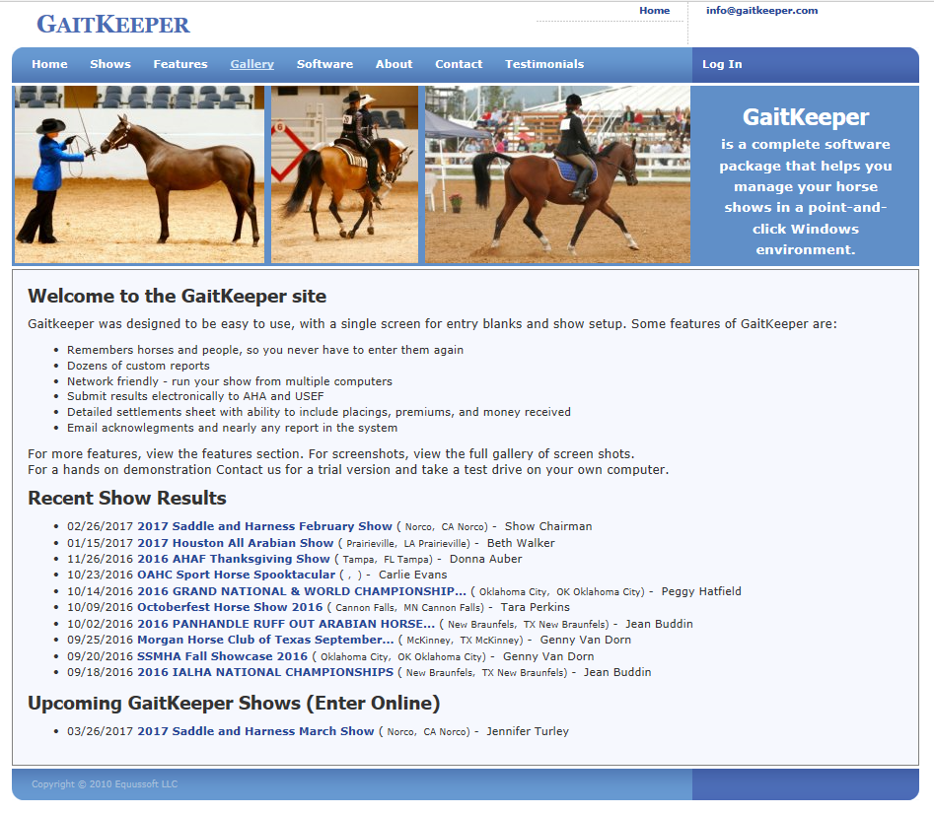

First Time users of GaitKeeper will need to Set up a Login and Password. Click on the Log In tab at the top right hand side of the screen. That will take you to the following Log In Screen.

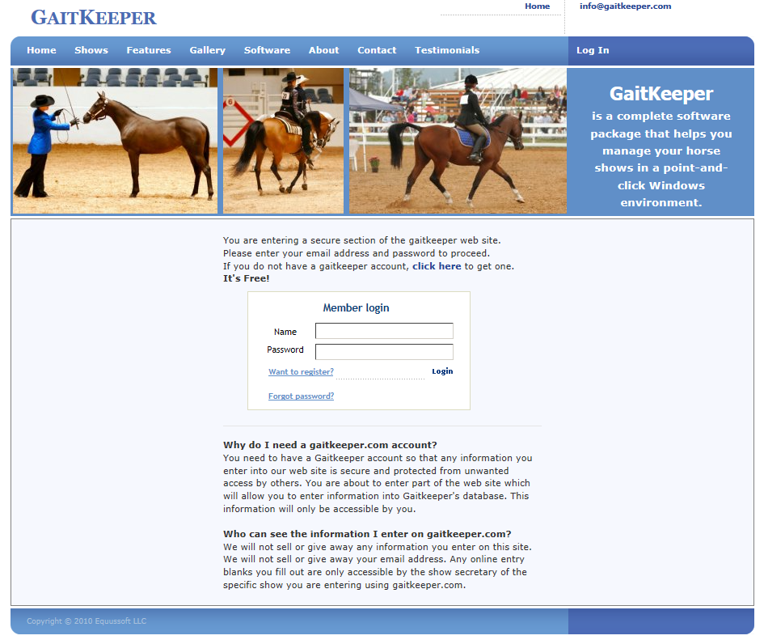

Click on the link “Want to register” and go through the steps to create a Log In.

When you Log In go to the Home Page and click on the link for the Show you want to “Enter Online”.
In this example I have selected the 2017 Saddle and Harness March Show.
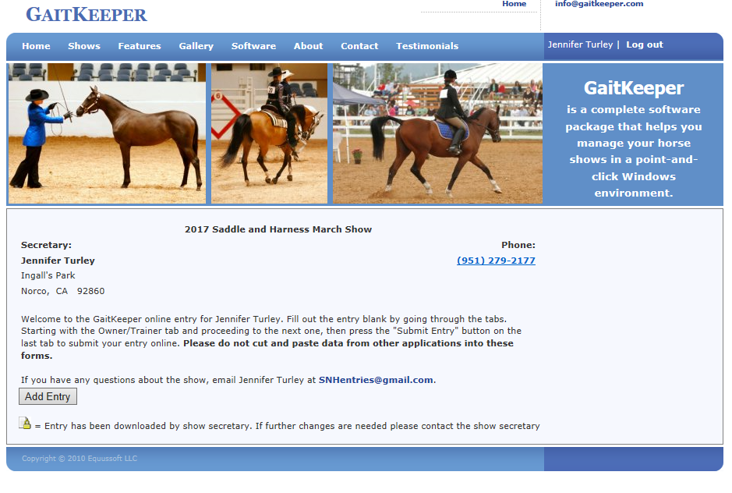

Click on the “Add Entry” Button which will take you to the next screen. Make sure to read the information on this screen.

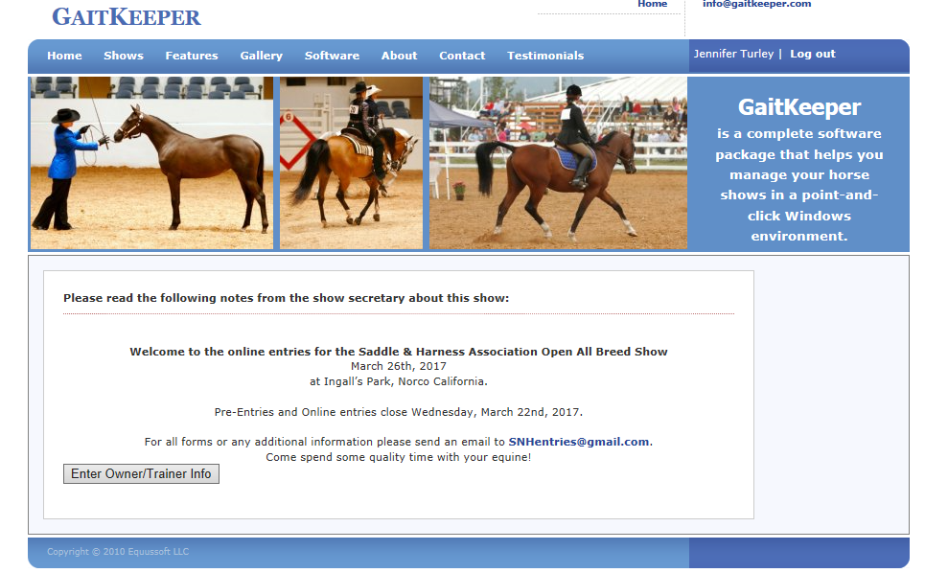

Next click on the “Enter Owner/Trainer Info” button which will take you to the next screen.

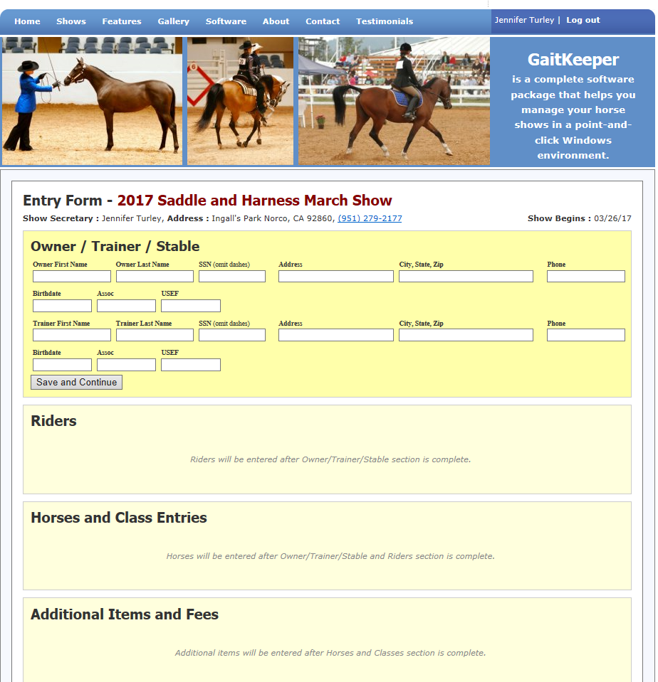

For Saddle and Harness entries the following fields of information are not required:
- Owner Birthdate
- Owner Assoc
- Owner USEF
- All Trainer information

When the Required Owner information is filled in, click on the “Save and Continue” button to get to the next screen.

Next step is to “Add Rider” which is adding the exhibitor that will be showing.
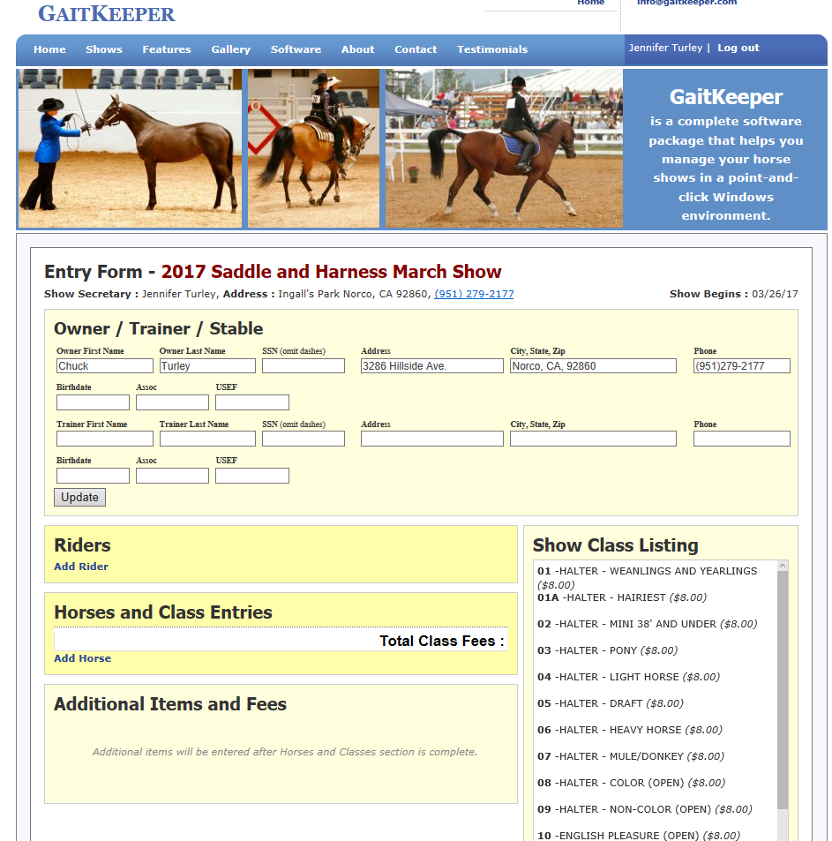

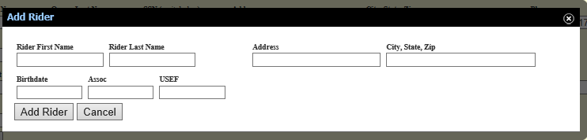
Fill in the First Name, Last Name, Address, City, State, Zip information. The system does require a Birthdate to be entered. For adults, this does not have to be your actual birthdate. Once this is completed, click on “Add Rider”.

When a Rider is successfully added they will be listed as shown below.

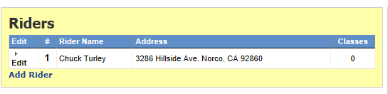

The next step is to “Add Horse”.

Fill out the Horse’s Name. Make sure to use the same name that you will be showing all year if you are competing for the Year End awards.
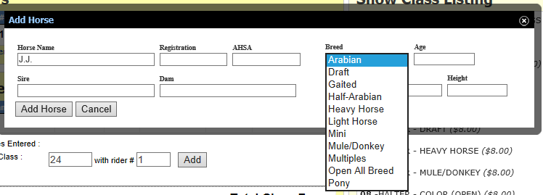

Next use the drop down selection for Breed. Select the “Division” that you will be showing in. DO NOT USE Arabian or Half-Arabian. If you are only showing in Halter or the Riding classes, you can use “Open All Breed”.

The final item needed for the horse set up is the Gender (i.e. Mare, Stallion, Gelding).

Then click on “Add Horse” button.

Now it is time to add classes for the Horse that has been added. Find the class number from the Class Listing that is located in the right hand side of the screen.
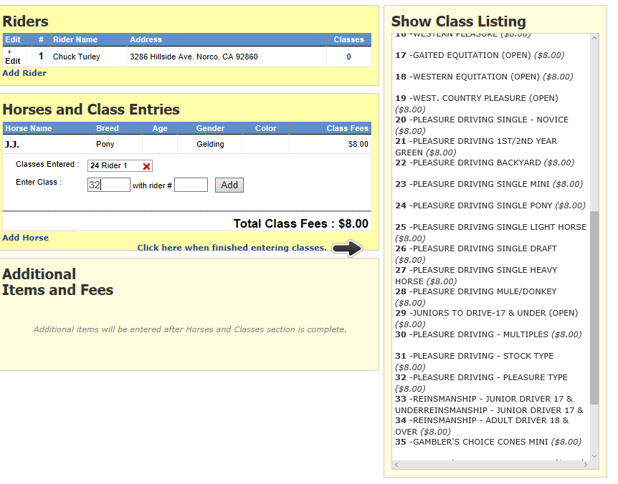

Type in the Class Number of the class that you want to show in. Then type in the Rider # from the add Rider list above.

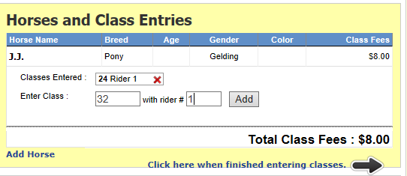

Then click on the “Add” button to add the class for the horse/rider combination. Note that the system is calculating the Entry Fees at the Pre-Entry rate which is good until the cutoff date. After that, the Post Entry Fee ($10.00) will be charged.

Note there is a red X in the Classes Entered box. If you click on it the class entered will be deleted.

When you are done entering classes, then click on the “Click here when finished entering classes” link. This will drop you down to the “Additional Items and Fees” box.
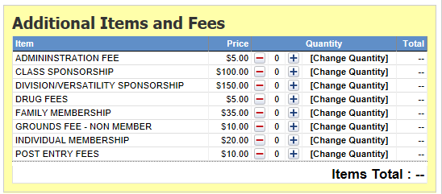

Click on the Plus or minus signs to increase or decrease the quantity on the line that you want to add or subtract items from.

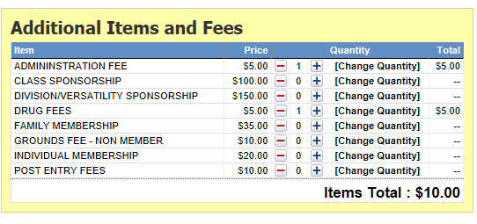

Every Horse/Rider combination must pay the Administration Fee and Drug Fee. If the Horse is being shown by multiple exhibitors, only 1 Drug fee must be paid. If Multiples are being shown, a drug fee must be paid for each individual equine.

All fees will be reviewed by the Show Committee and you will be notified if there are any corrections needed.

When you are done with the Additional Items and Fees, click on the “Click here to continue to the payment/confirmation screen” link.

The confirmation screen will appear with the total that the system has calculated. At this time, the only payment method Saddle and Harness accepts is “Pay at Show”.

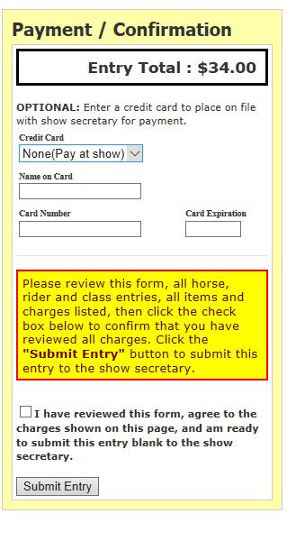

When you are finished, click in the box indicating you have reviewed the form and agree to the charges show. Then click on the “Submit Entry” button.

Then final screen is a Confirmation that your entry has been submitted. This page can be printed out for your records.

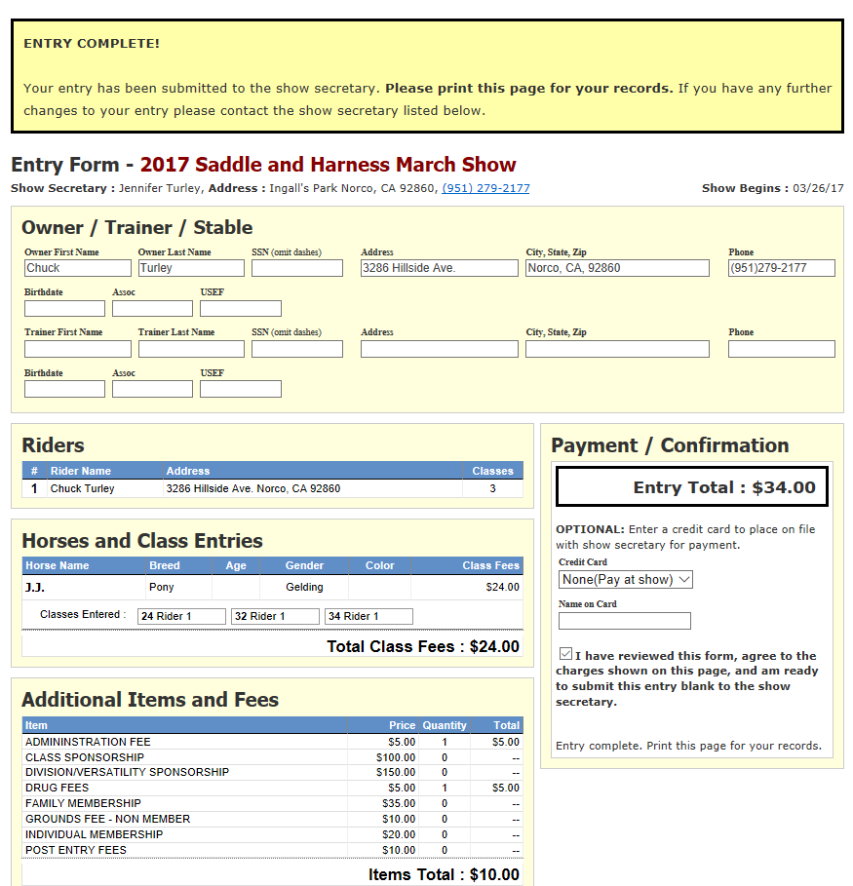

Once the Saddle & Harness Show Secretary has processed the Entry, a confirmation email will be sent with the total payment due. Payments can be mailed or collected the day of the show.

If you need to make changes to any submitted entry, you will need to email the changes to the Show Secretary at SNHentries@gmail.com.

